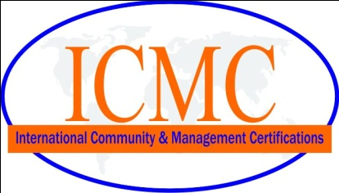
APPLICATION FOR REGISTRATION Date:- _________________________

Please complete and return this questionnaire to enable International Community & Management Certifications. to accurately prepare a quotation for your organization. If additional information is required, then ICMC will contact you before sending a quote.
Name of organization

Physical address | Postal Address
Contact person :
Designation :
Telephone no. : Extn.:
Mobile no. :
E-mail address :
Certification Standard(s): ISO 9001:2008 ISO14001:2004 ISO18001:2007
ISO 27001:2005 ISO 13485:2003 ISO22000:2005 HACCP
GMP ISO/TS16494 TQM CE Marking
Six sigma Other Standard
Do you design the product:
No. of sites:
Effective No. of Employee | To calculate the effective no of employees, subtract duplication due to shift work.
Scope of Certification:

Significant aspect in processes/Pollutant | List of Process
Specific Statutory and legal requirement(s) | Layout of Plant/Office

Yes | No
 |  | Are the systems integrated
 |  | Do you want a preliminary audit | When
 |  | Are you ready for audit | When
 |  | Are the systems implemented | How long
 |  | Did consultants help you in develop your system | Who
 |  | Are you certified by some one else | Who
I have read, understood and agree on the terms and conditions written on the back of this form.

Applicant Signature

Seal of company

For ICMC Office use only |  | Sample procedure | Comments
 | Resources reviewed
 | Resources adequate
 | Man days required
 | Quotation sent

IC001.01

