30-Sep-2015 | 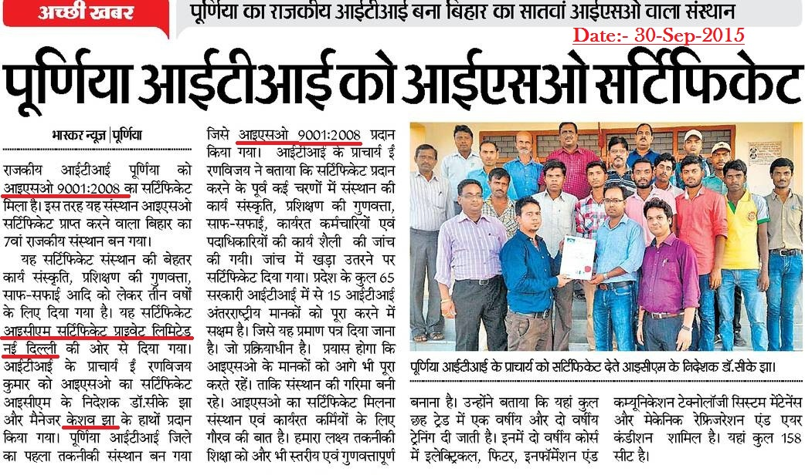
Dainik Bhasakar- Purinia Edition
 | 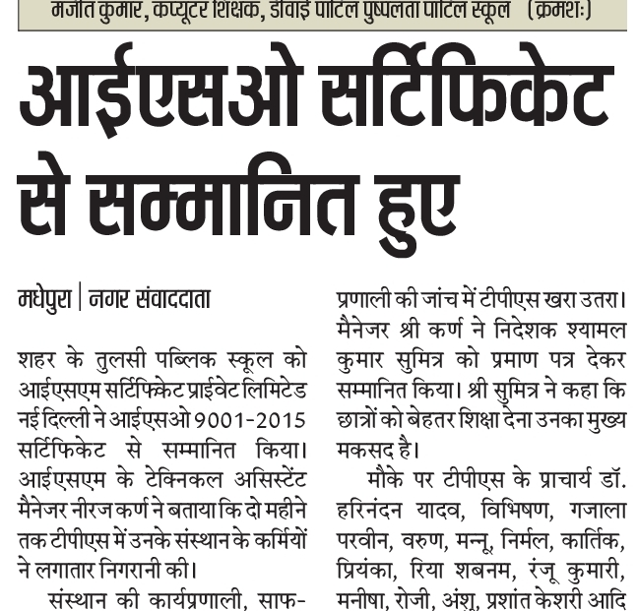
Hindustan Times- Madhepura Edition
 | 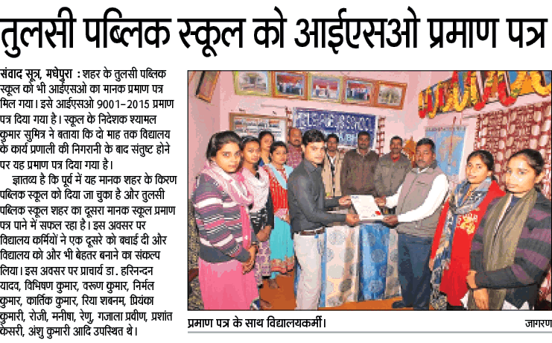
Dainik Jagran Madhepura Edition
02-Aug-2015 | 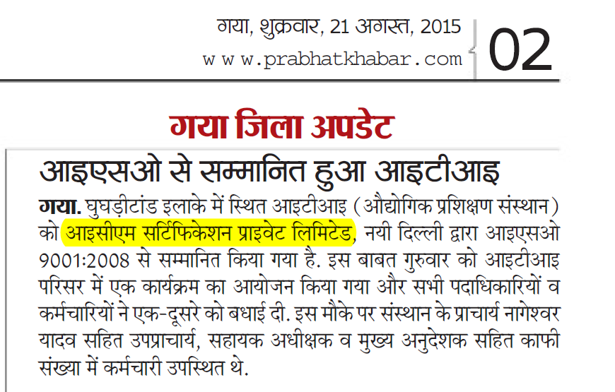
PrabhatKhabar Gaya Edition
28-Nov-2015 | 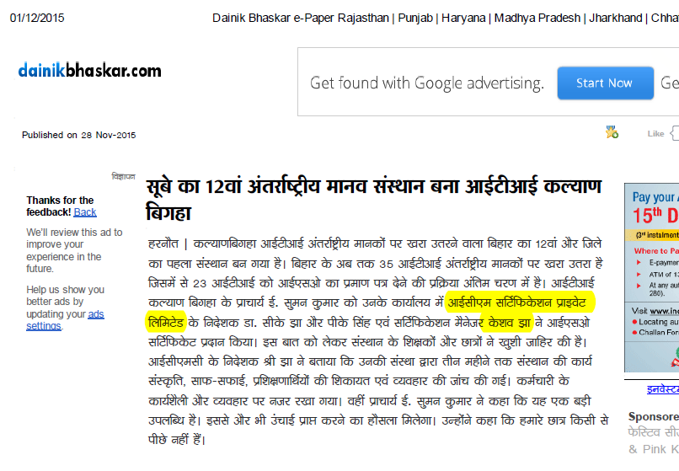
DainikBhasakar-Biharsarif Edition
 | 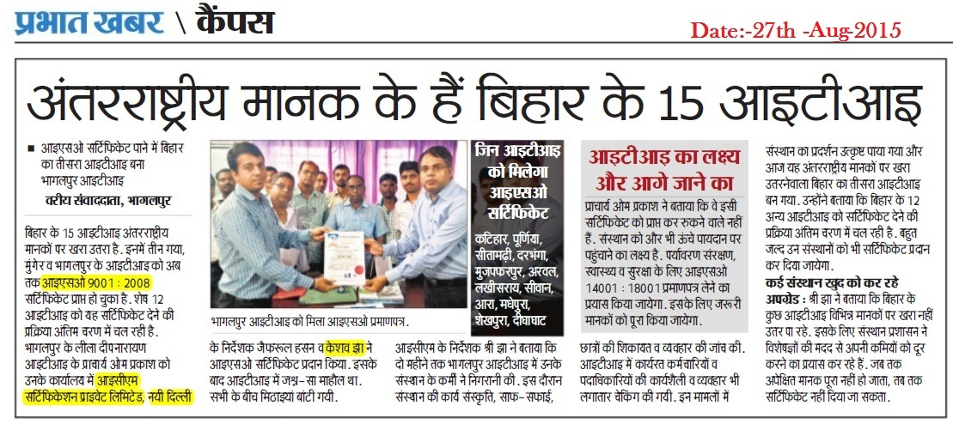
27-Aug-2015
PrabhatKhabar- Bhagalpur Edition

31-Jul-2016 | 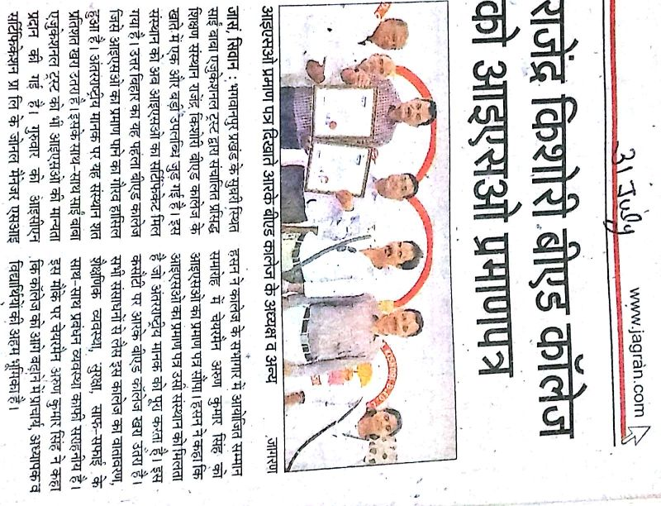
Dainik Jagarn- Siwan Edition
11-Aug-2016  Dainik Jagarn-Muzaffarpur Edition | 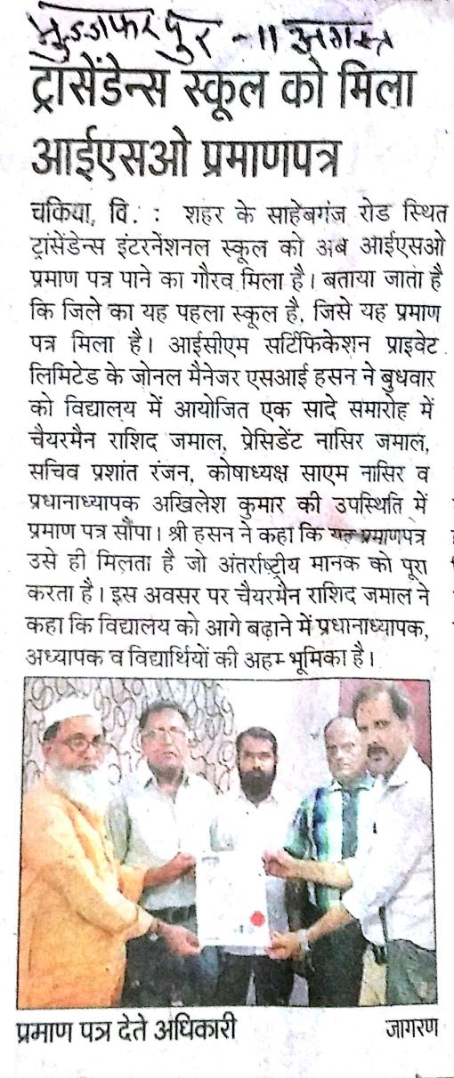

18-Aug-2016 | 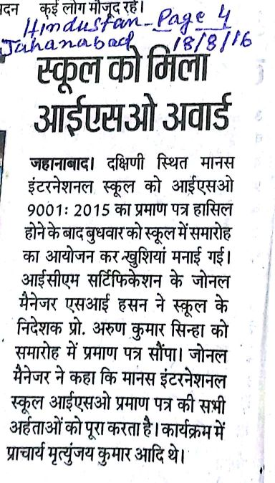
Hindustan Times- Jahanabad Edition

30-Jul-2016 | 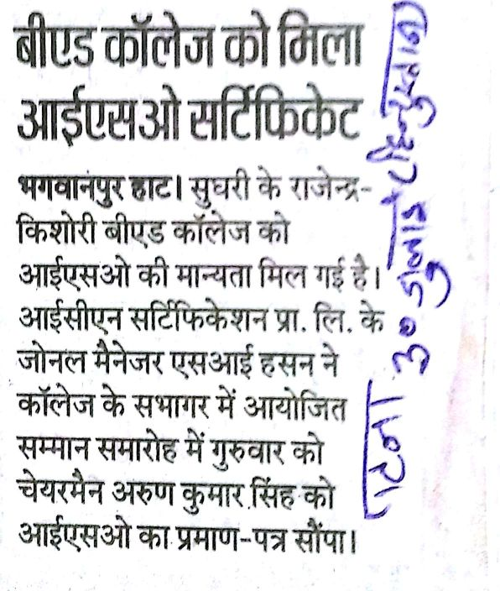
Hindustan Times- Patna Edition

18-Aug-2016 | 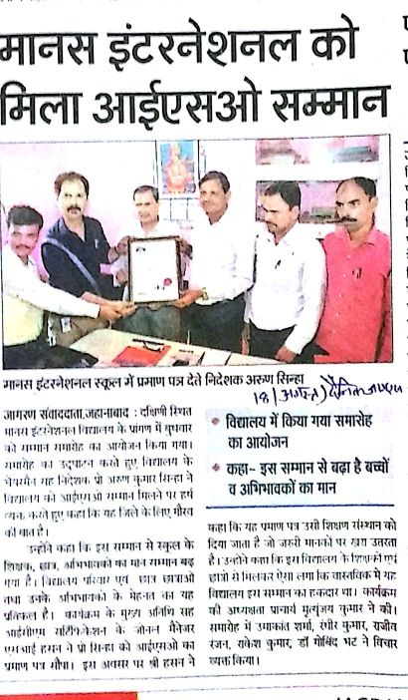
Dainik Jagarn- Jahanabad Edition

18-Aug-2016 | 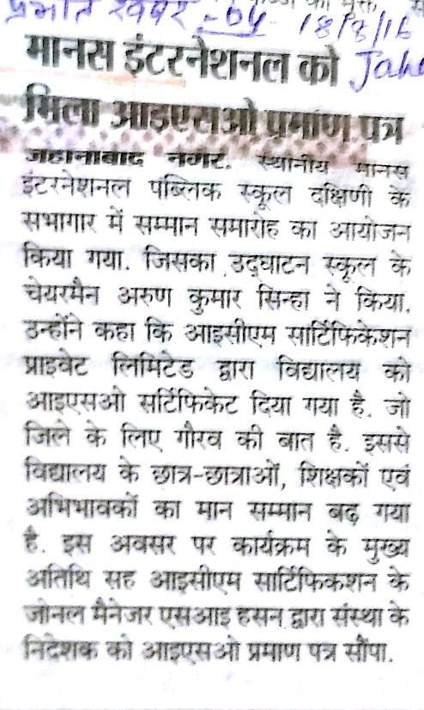
PrabhatKhabar
-Jahanabad edition

